Bare International Analysis Report(Excel)
Name: Maitreyee Khachane
Course: Data Analytics
Batch: CX-167-MOR-JAN-OFFLINE

OBJECTIVE:
- To assign performance grades to Style Advisors based on Evaluation Scores.
- Analyse regional performance using pivot tables and average scores.
- Identify the region with the highest proportion of High Performers.
- Visualise key insights using charts and dashboards.
- Present findings with actionable recommendations for management decision-making.

DATASET DESCRIPTION:
Column Name | Description
Evaluation_ID | Unique identifier for each evaluation record
Evaluation_Date | Date on which the evaluation was conducted
Evaluation_Score | Overall score assigned for the evaluation
STORE AMBIANCE, FIRST IMPRESSIONS, DISCOVERY, etc. | Key evaluation criteria used to assess performance
Location_City | City where the evaluation took place
Location_State | State of the evaluation location
Zone | Region classification (North, South, East, West)
Location_Country | Country of the evaluation
Time of Entry | Time when the auditor entered the store
Time of Exit | Time when the auditor exited the store
Duration of Visit (seconds) | Total time spent during the evaluation
Style Advisors Present | Number of advisors present during the visit
Customers Present | Number of customers present during the visit
Age of Auditor | Age of the auditor conducting the evaluation
Gender of Auditor | Gender of the auditor
Auditor Attire | Attire worn by the auditor during evaluation
Style Advisor Name | Name of the advisor being evaluated
Style Advisor Description | Additional details about the advisor
Evaluation Criteria (e.g., Signage, Greeting, Communication, Closure, Care) | Specific parameters used to measure service quality

DATA CLEANING AND ANALYSIS PERFORMED
DATA CLEANING:
- Checked for missing and null values in the dataset.
- Standardised date and time formats for accurate time-based analysis.
- Ensured numerical columns such as Evaluation Score and criteria scores were correctly formatted.
- Removed inconsistencies and ensured data accuracy across all fields.
- Organised and structured data for efficient pivot table analysis.

ANALYSIS PERFORMED:

- Assigned performance grades (High, Average, Low, Bottom) using the IFS function based on the Evaluation Score.
- Calculated average evaluation scores across different zones.
- Identified the percentage of High Performers in each region.
- Created pivot tables to compare performance across zones.
- Analysed performance trends over time using line charts.
- Compared High vs Low performers using stacked bar charts.
- Evaluated performance across multiple criteria such as Greeting, Communication, Closure, and Care.
- Created visualisations including bar charts, pie charts, and heatmaps.
- Built an interactive dashboard using pivot tables and slicers.

DASHBOARD

DESCRIPTION: An interactive dashboard was created to visualize advisor performance across zones, trends over time, and comparison of performance categories. Slicers were used to enable dynamic filtering.
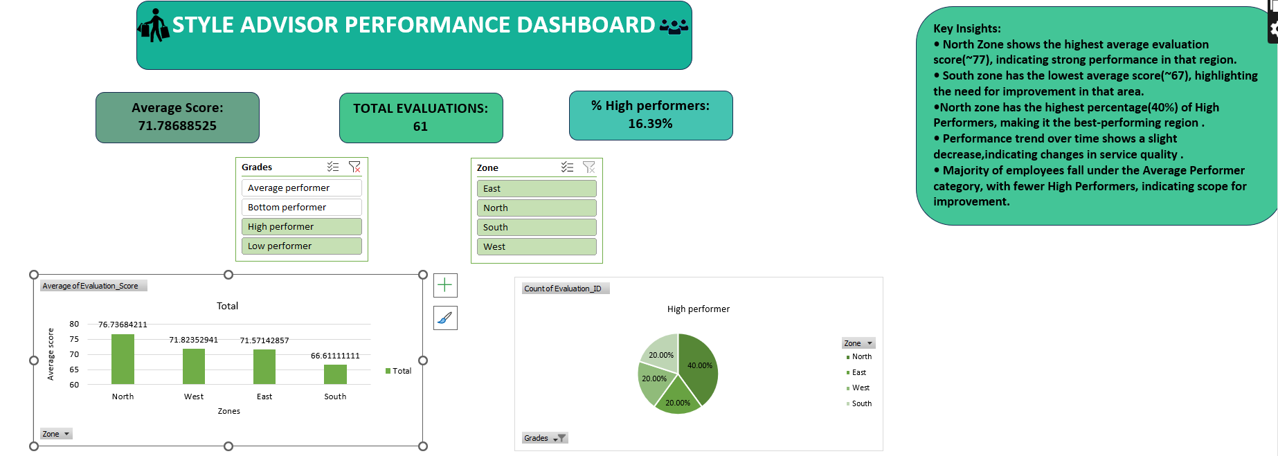
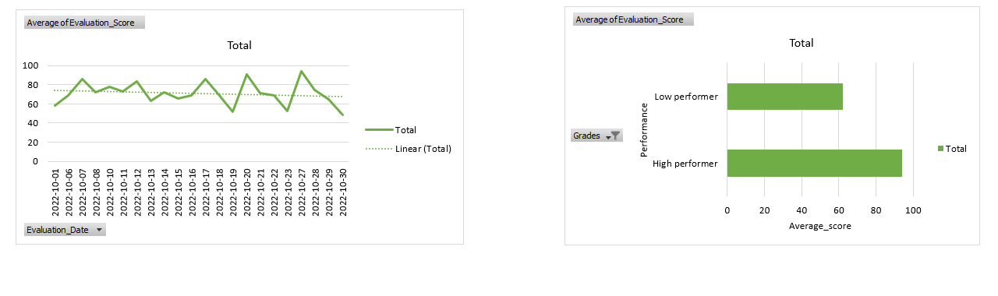
KEY INSIGHTS:
• North Zone shows the highest average evaluation score(~77), indicating strong performance in that region.
• South zone has the lowest average score(~67), highlighting the need for improvement in that area.
•North zone has the highest percentage(40%) of High Performers, making it the best-performing region .
• Performance trend over time shows a slight decrease, indicating changes in service quality.
• The majority of employees fall under the Average Performer category, with fewer High Performers, indicating scope for improvement.

CONCLUSION:
The analysis provides valuable insights into the performance of Style Advisors across different regions. It highlights variations in evaluation scores, identifies high-performing zones, and brings attention to areas that require improvement. The visualisations clearly demonstrate performance trends, distribution of performance categories, and differences across evaluation criteria. Regions with a higher proportion of High Performers indicate effective practices, while lower-performing regions highlight opportunities for targeted improvement.

RECOMMENDATIONS:
• Focus on improving performance in low-performing regions such as South by providing targeted training and support.
• Encourage adoption of best practices from high-performing regions like North to maintain consistency across all zones.
• Provide training programs focused on key evaluation criteria such as communication, customer engagement, and closure.
• Regularly monitor performance trends to identify declines early and take corrective actions.
• Implement performance-based incentives to motivate Style Advisors to achieve higher scores.
• Develop strategies to convert Average Performers into High Performers through coaching and feedback.
• Ensure consistent service standards across all locations to improve overall customer experience.

